EXPT NO:6 | IMPLEMENTATION OF MULTIVARIATE DISPLAYS
DATE: 24.01.2026 | IMPLEMENTATION OF MULTIVARIATE DISPLAYS

PRE-LAB QUESTIONS
- Why are multivariate displays important in AI analytics?
Multivariate displays allow analysts to visualize and explore relationships among multiple variables simultaneously, rather than examining one or two at a time. In AI analytics, models often depend on many features, and multivariate visualizations help identify patterns, correlations, clusters, and anomalies within high-dimensional data. They support better feature selection, detection of multicollinearity, and understanding of complex interactions, which ultimately improves model design and performance.

- How do parallel coordinates differ from scatter plots?
A scatter plot displays the relationship between two variables using points on x and y axes. Parallel coordinates, on the other hand, represent many variables at once by drawing each variable as a vertical axis and connecting data points with lines across axes. While scatter plots are simple and intuitive for pairwise analysis, parallel coordinates are better suited for high-dimensional datasets.

- What challenges exist in interpreting multivariate plots?
Multivariate plots can become visually cluttered when datasets are large, making patterns difficult to see. Overlapping points or lines may hide important relationships. Additionally, interpreting many variables at once requires cognitive effort, and poor color choices or scaling can mislead users. Proper normalization, filtering, and interactive tools are often needed to overcome these issues.

- Where are trellis displays commonly used?
Trellis displays (also called small multiples) are commonly used in statistical analysis, machine learning exploration, and time-series analysis. They show the same type of plot repeated across subsets of data, enabling easy comparison between groups such as categories, classes, or time periods. This helps analysts observe consistent patterns and differences.

- How does multivariate visualization aid model evaluation?
Multivariate visualization helps assess how input features relate to predictions and errors. It allows analysts to compare predicted vs. actual values across multiple dimensions, detect bias, identify outliers, and understand feature influence. This visual feedback supports model debugging, tuning, and validation.

OBJECTIVE : To implement advanced multivariate displays for complex data analysis.

SCENARIO A retail analytics firm studies sales, profit, customer segment, and region to optimize business strategy.

IN-LAB TASKS (Using R Language) • Create parallel coordinate plots • Generate bubble charts • Implement trellis displays by region

CODE:
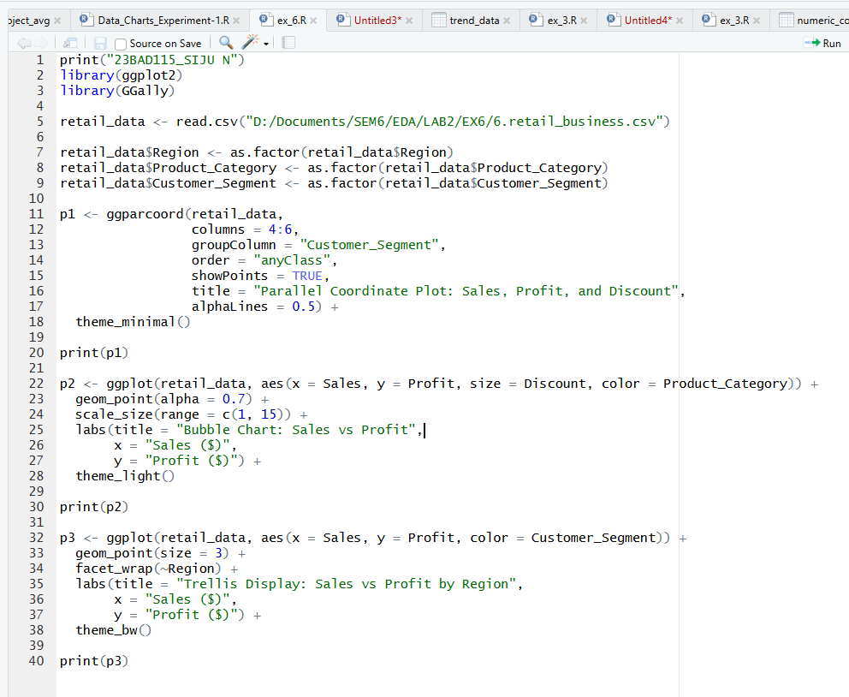
OUTPUT:
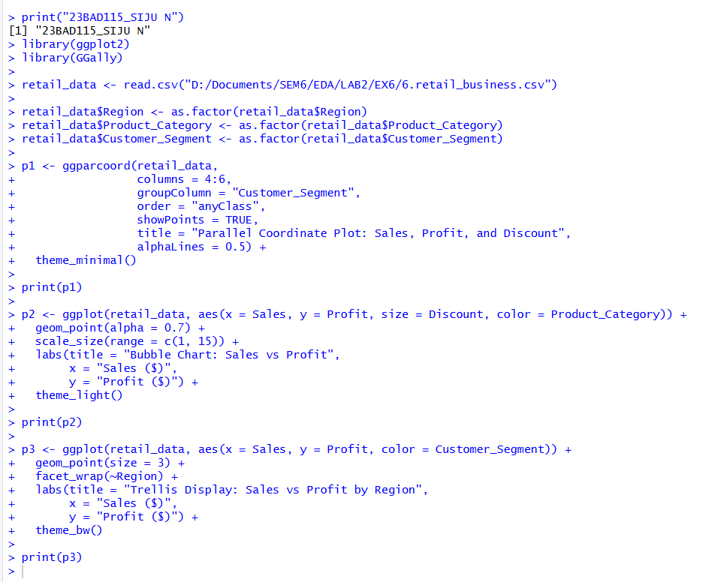

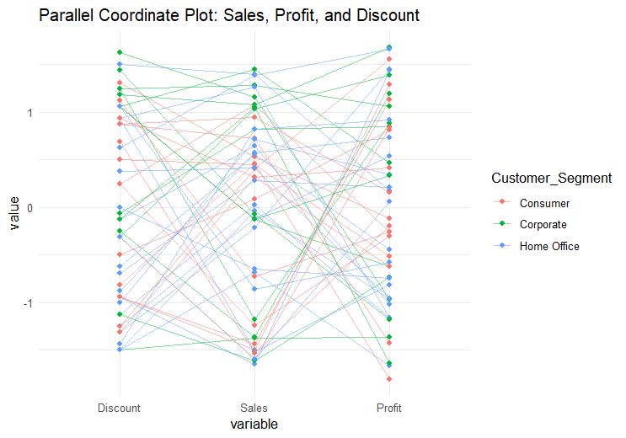

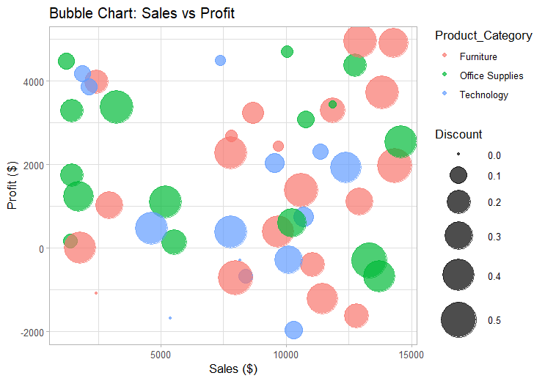
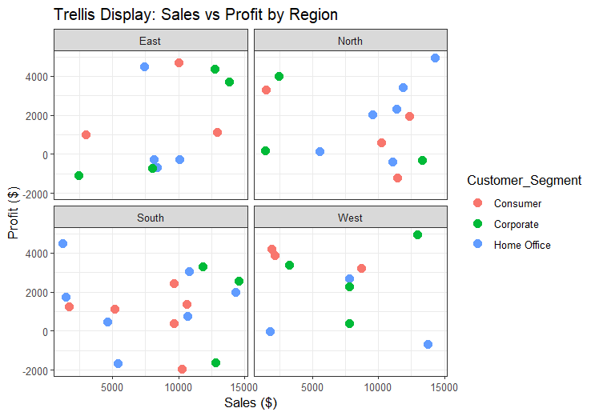

POST-LAB QUESTIONS
- What insights are gained from parallel coordinates?
The parallel coordinate plot shows how Discount, Sales, and Profit vary together across different customer segments. From the plot, we can observe that high discounts do not always lead to high profits, and in some cases, higher discounts align with lower profits. It also reveals variations in sales and profit patterns among Consumer, Corporate, and Home Office segments. This helps identify combinations of variable values that are associated with profitable or unprofitable transactions.

- How does faceting simplify complex data?
Faceting divides the dataset into smaller subsets based on Region (East, North, South, West) and displays each subset in a separate panel. This makes it easier to compare sales–profit relationships across regions without clut ter. Patterns such as regions with consistently higher profits or regions showing more losses become clearer than in a single combined plot.

- What limitations exist in bubble charts?
Bubble charts can become difficult to interpret when many bubbles overlap. It is sometimes hard to accurately compare bubble sizes representing discount values. Also, when too many variables (position, color, size) are encoded at once, it may confuse viewers and reduce readability.

- How can these displays support AI-driven recommendations?
These visualizations help identify patterns such as which product categories generate higher profit at certain sales ranges and which customer segments are sensitive to discounts. AI systems can use such insights to recommend optimal discount levels, prioritize profitable product categories, and suggest region-specific or segment-specific marketing strategies.

- Suggest improvements for large multivariate datasets.
  - Use interactive dashboards with filtering and zooming.
  - Apply dimensionality reduction (e.g., PCA) before visualization.
  - Use sampling or aggregation to reduce clutter.
  - Include brushing and linking between plots.
  - Normalize or scale variables consistently.
LEARNING OUTCOME: Students apply multivariate visualization for business intelligence.

ASSESSMENT
Description | Max Marks | Marks Awarded
Pre Lab Exercise | 5
In Lab Exercise | 10
Post Lab Exercise | 5
Viva | 10
Total | 30
Faculty Signature

